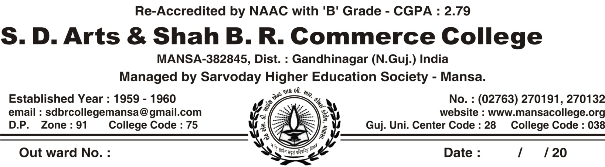

**REGULAR ACTIVITY OF CWDC COMMITTEE, MANSA COLLEGE (2021-22)**

|  |  |  |  |  |
| --- | --- | --- | --- | --- |
| **SR.NO** | **DATE** | **NAME OF ACTIVITY** | **NUMBER OF PARTICIPANTS** | **COLLABORATION WITH** |
| 1. | 6/7/2021 | Organized Lecture On **“ Sensible Woman Overwhelmed Corona”** | 15 | By CWDC Committee Mansa College Its Self |
| 2. | 4/9/2021 To 10/9/2021 | Organized Quiz Competition On “**Women Empowerment”** | 426 | By CWDC Committee Mansa College Its Self |
| 3. | 18/9/2021 | Organized Visit To Shri Vighneswari Charitable Trust Mansa | 31 | By CWDC Committee Mansa College Its Self |
| 4. | 27/9/2021 | Organized Seminar On **“The Conversion Of Short Film”** | 129 | Speaker – Kajalben Trivedi  By CWDC Committee Mansa College Its Self |
| 5. | 1/10/2021 | Organized Lecture On **“ Health Sanitary Pad”** | 73 | Speaker – Miliben H Desai & Ushaben  By CWDC Committee Mansa College Its Self |
| 6. | 3/3/2022 | Celebration Of **“International Women Day”**  & Organized A Program Of Film Songs As A Tribute To Shri Lata Mangeshkar | 75 | By CWDC Committee Mansa College Its Self |
| 7. | 8/3/2021 To 13/3/2022 | Organized Quiz Competition On **“ Biography Of Lata Mangeshkar”** | 548 | By CWDC Committee Mansa College Its Self |
| 8. | 8/3/2022 | Organized Elocution Program On **“Woman’s Upliftment”** | 10 | Speaker – Jagrutiben Pandya  At Shri Vighneswari Charitable Trust Mansa |

**Organized Visit To Shri Vighneswari Charitable Trust Mansa 18/9/2021**

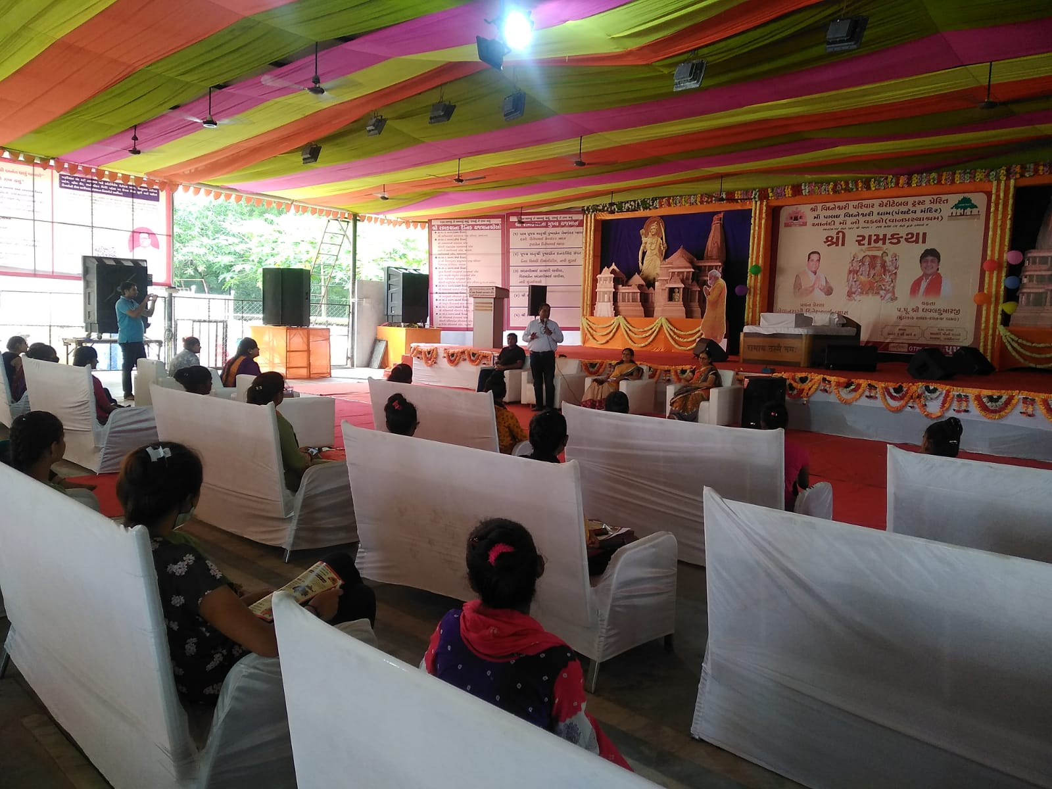

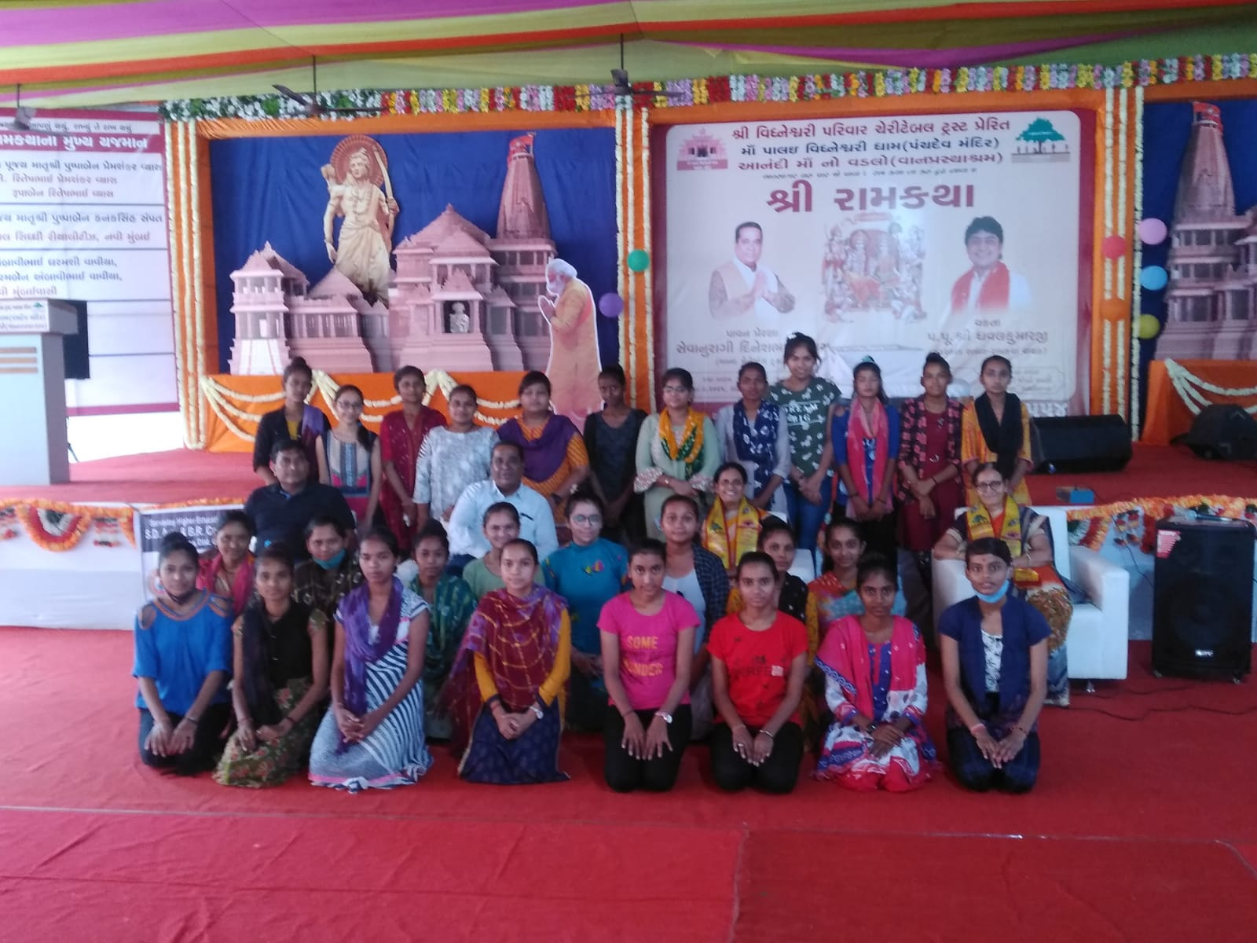

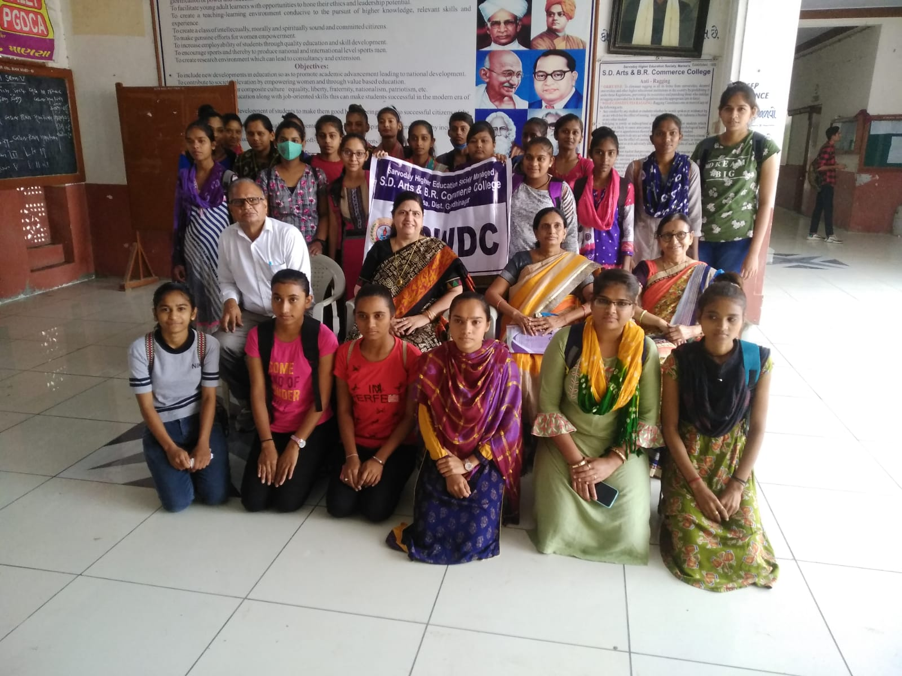

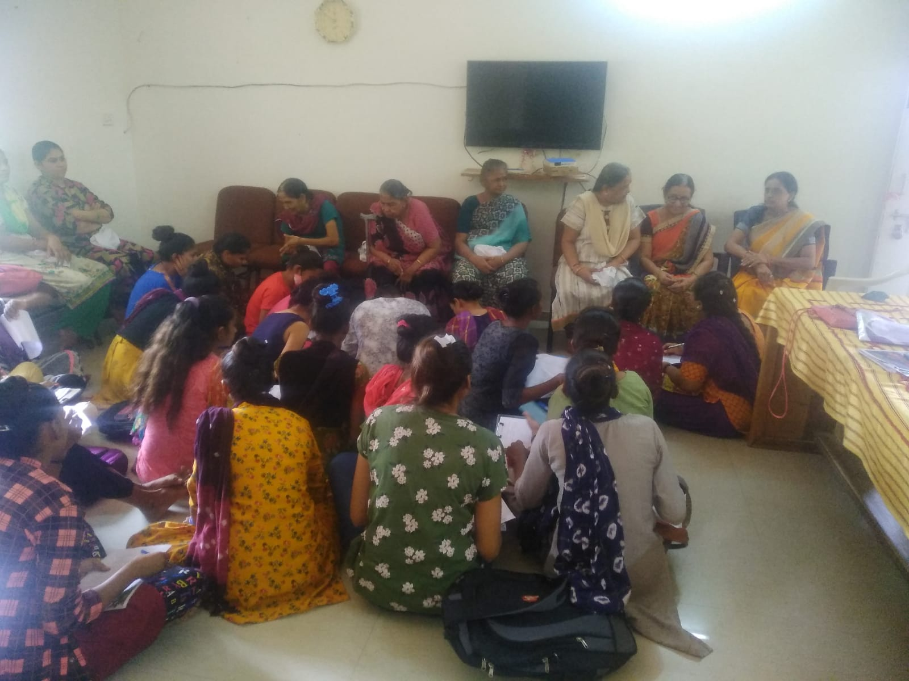

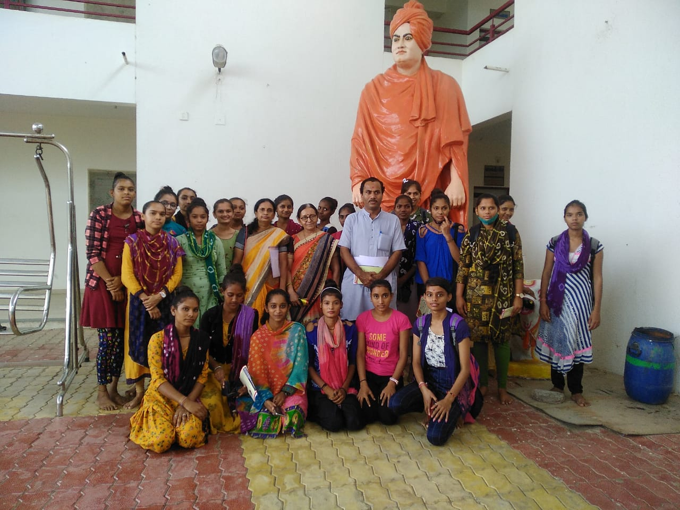

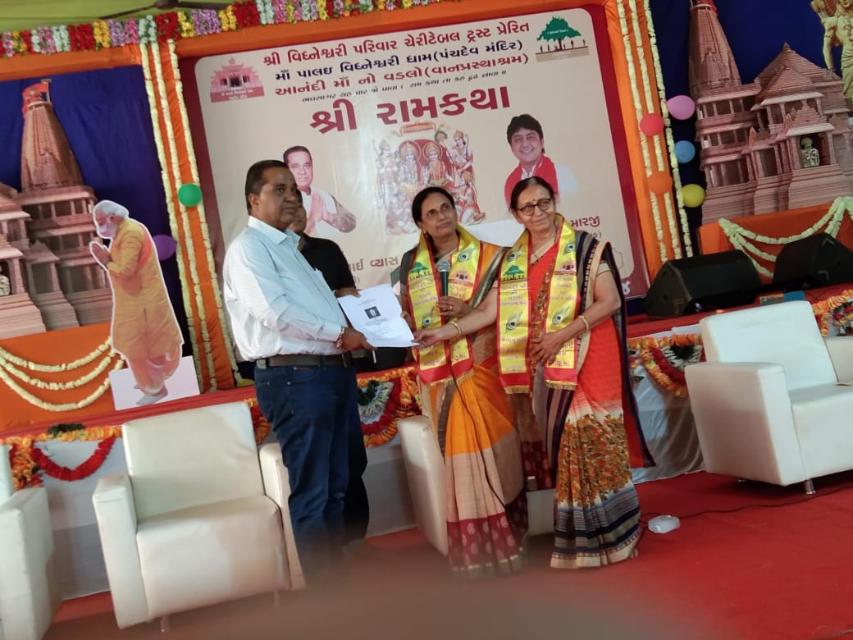

Organized Seminar On **“The Conversion Of Short Film”** 27/9/2021

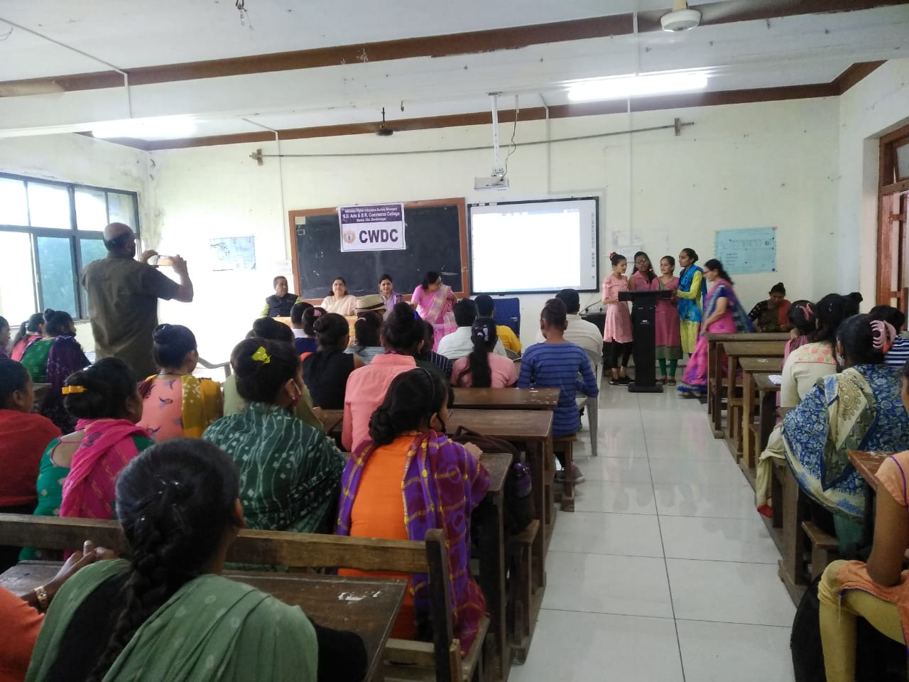

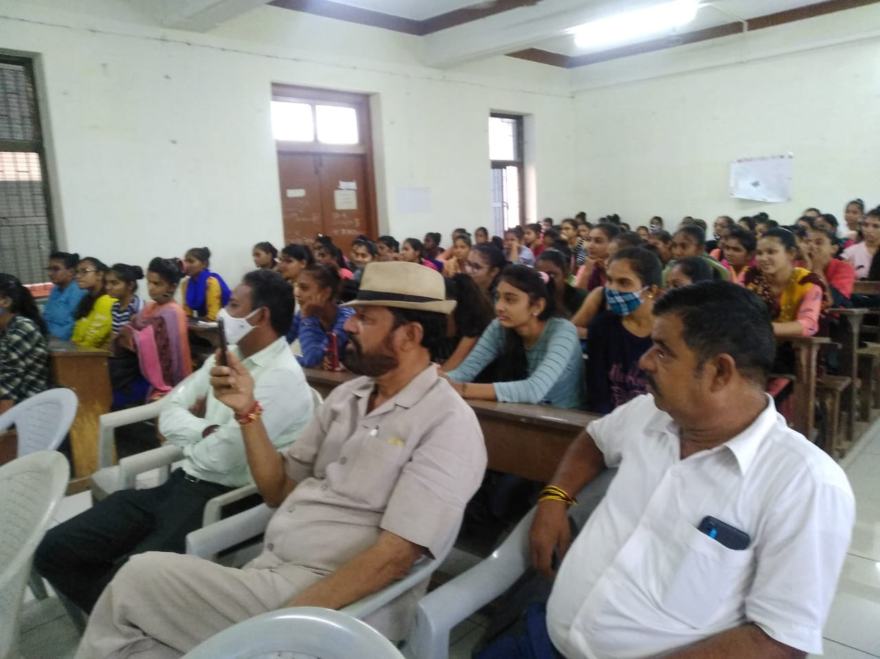

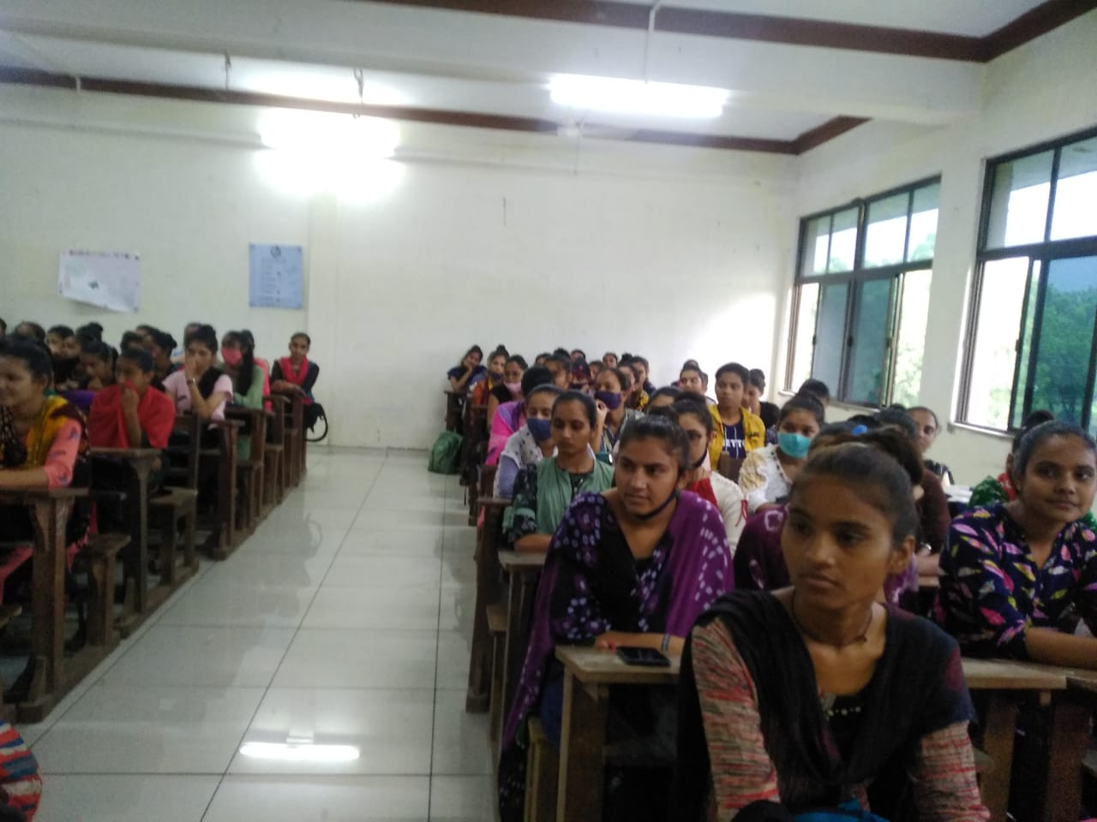

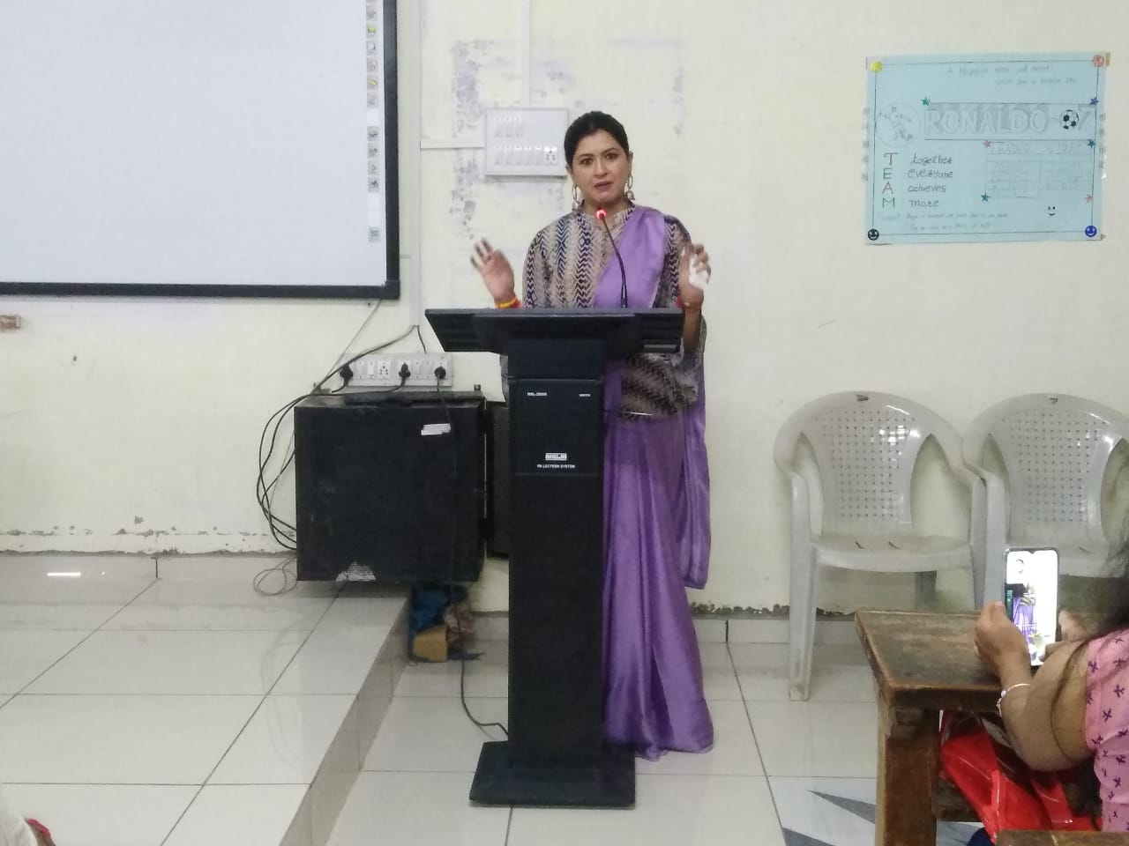

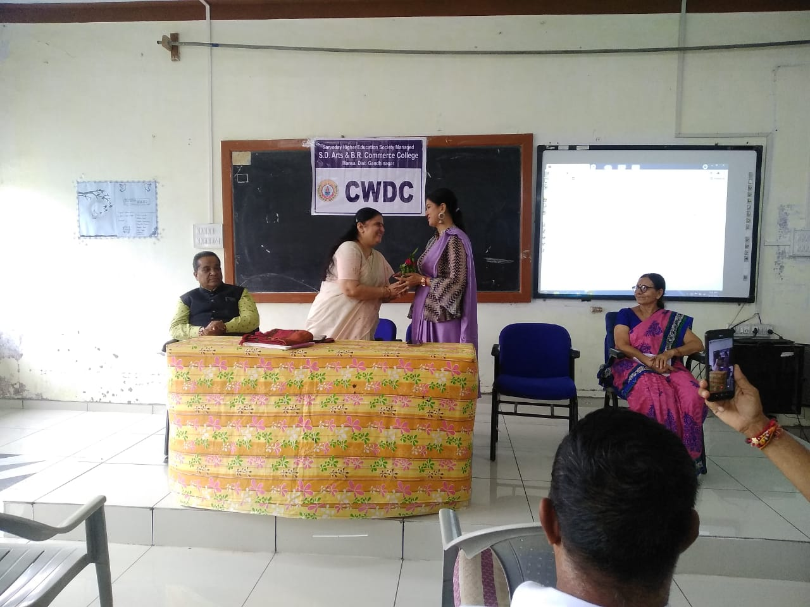

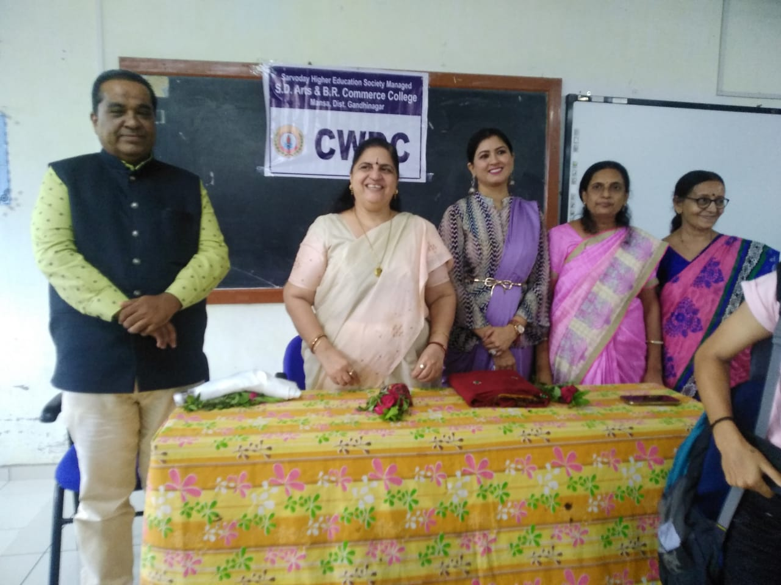

Organized Lecture On **“ Health Sanitary Pad” 1/10/2021**

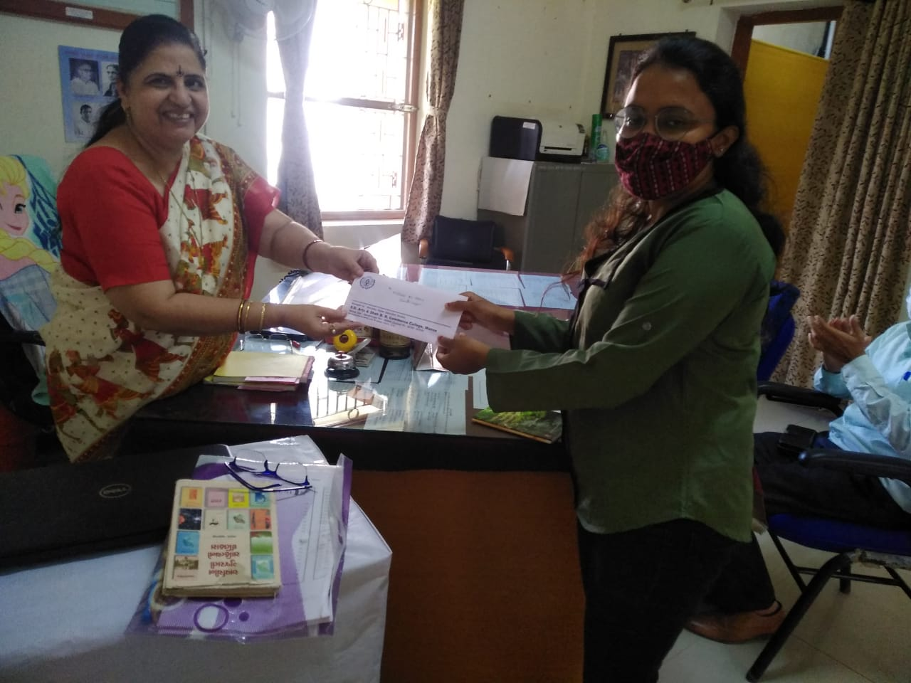

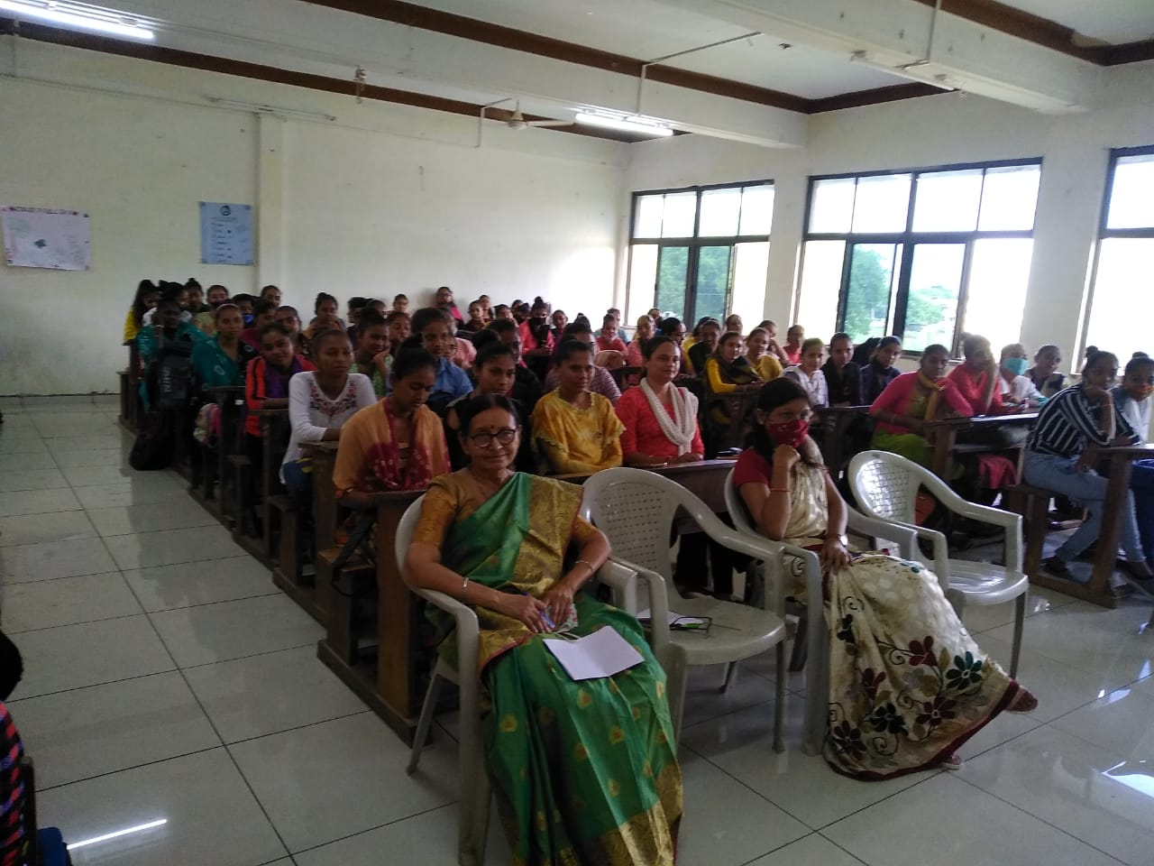

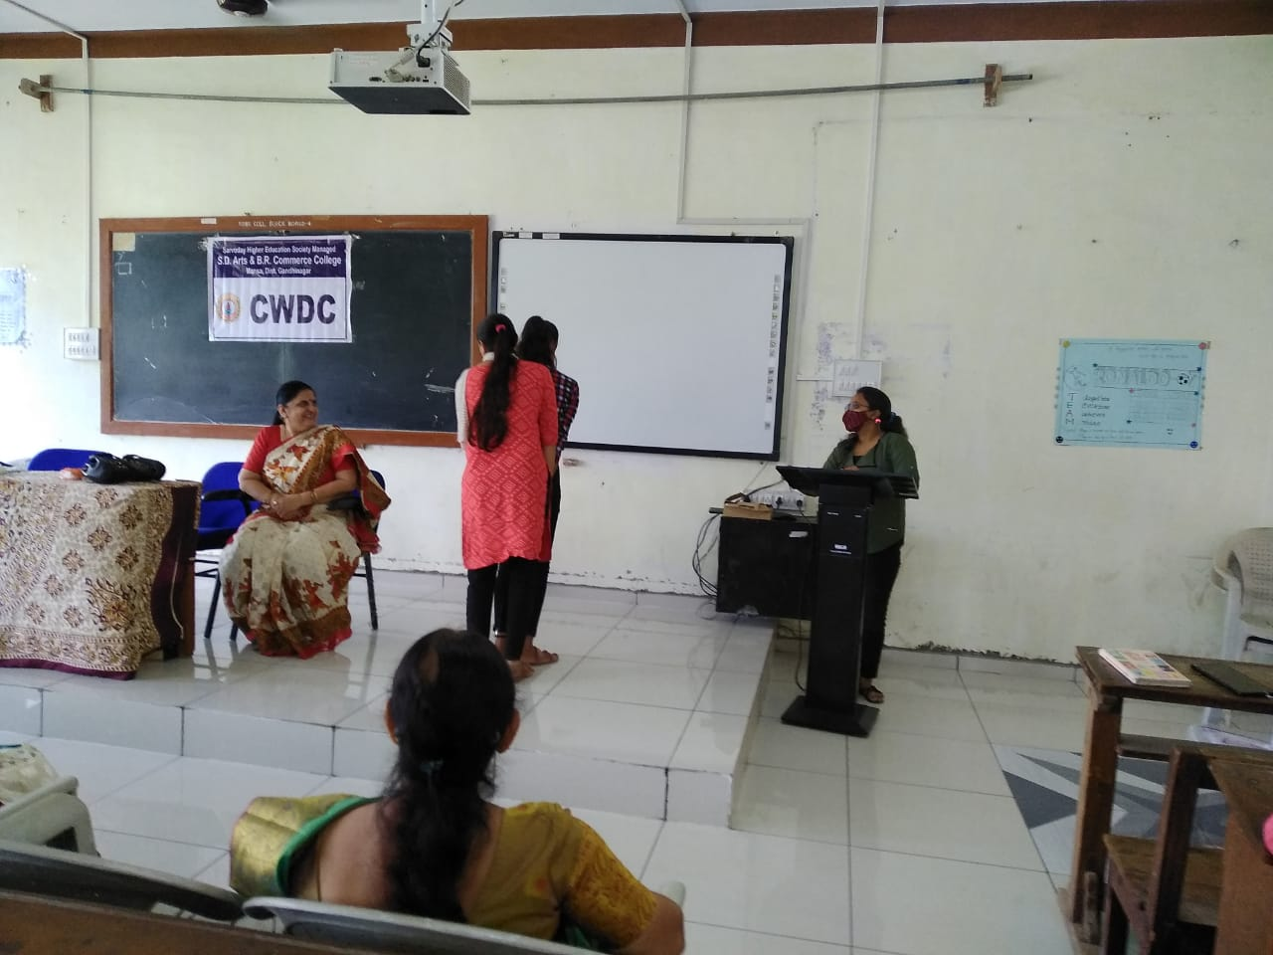

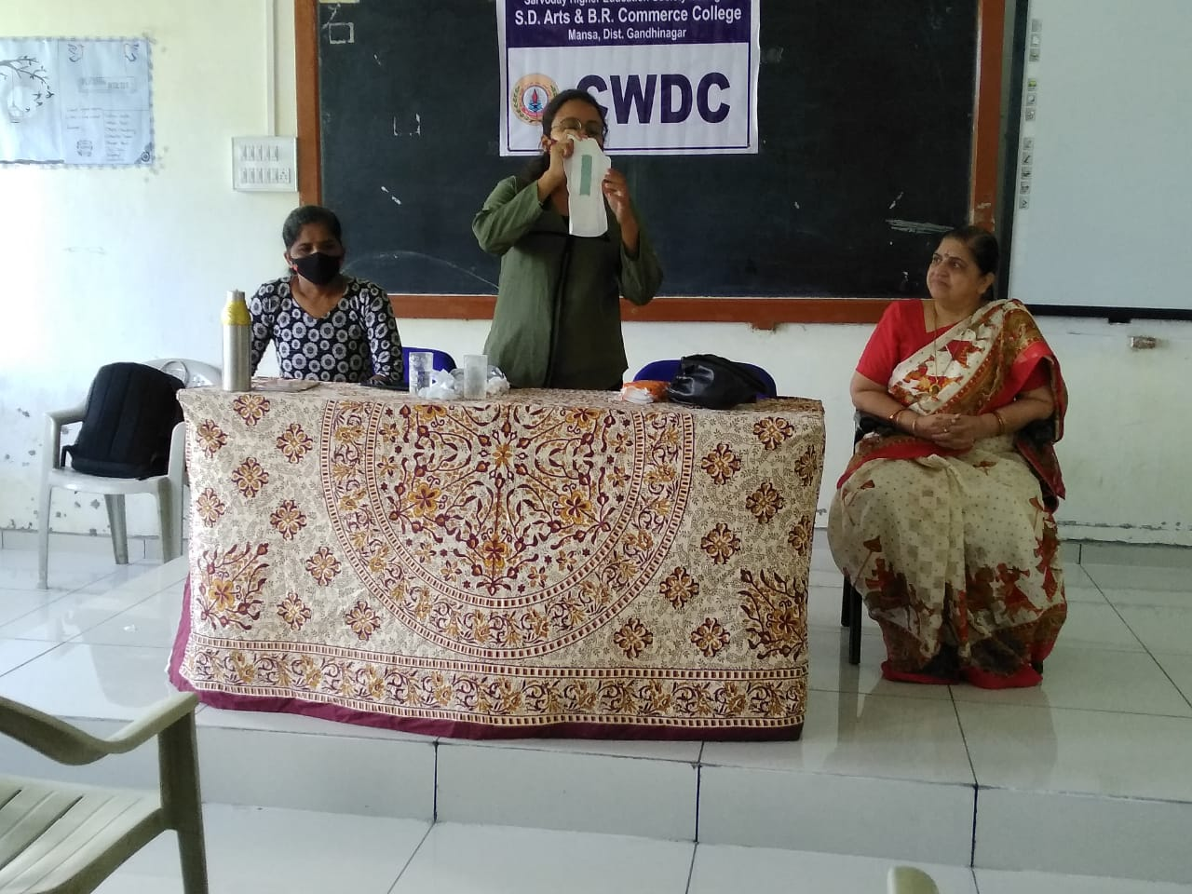

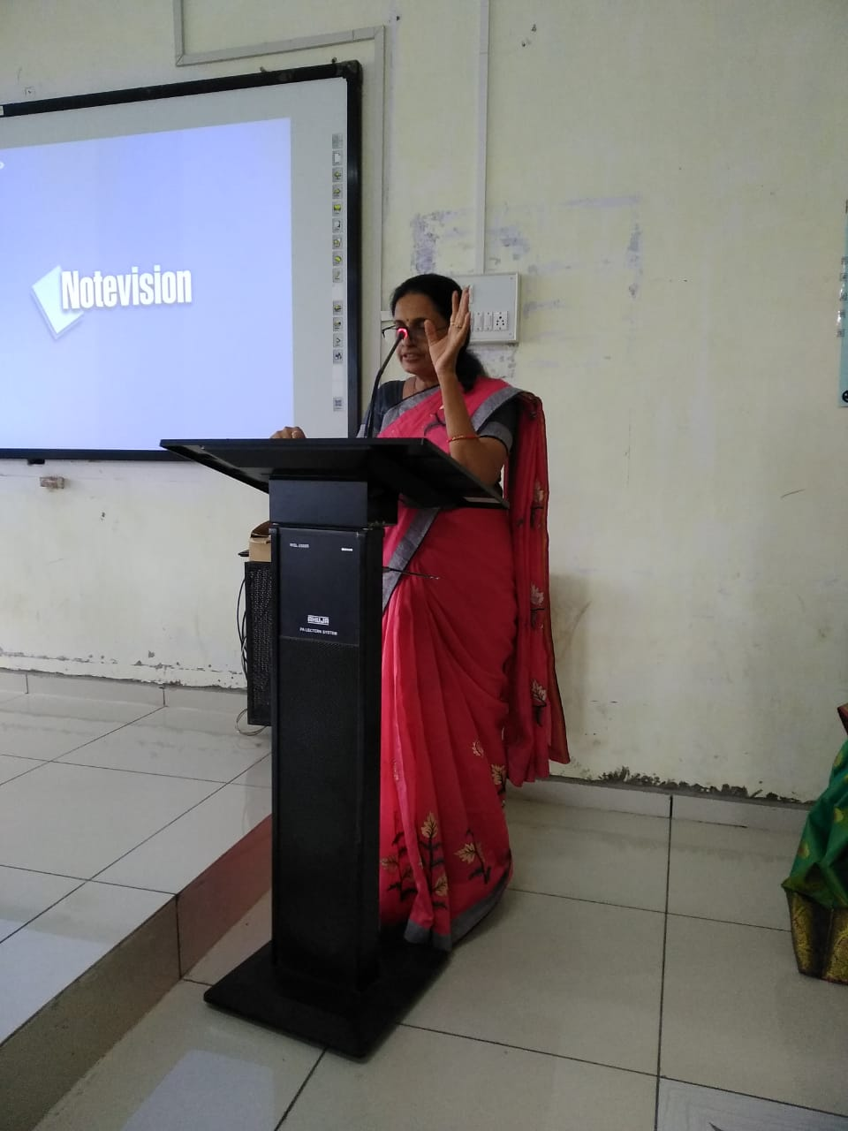

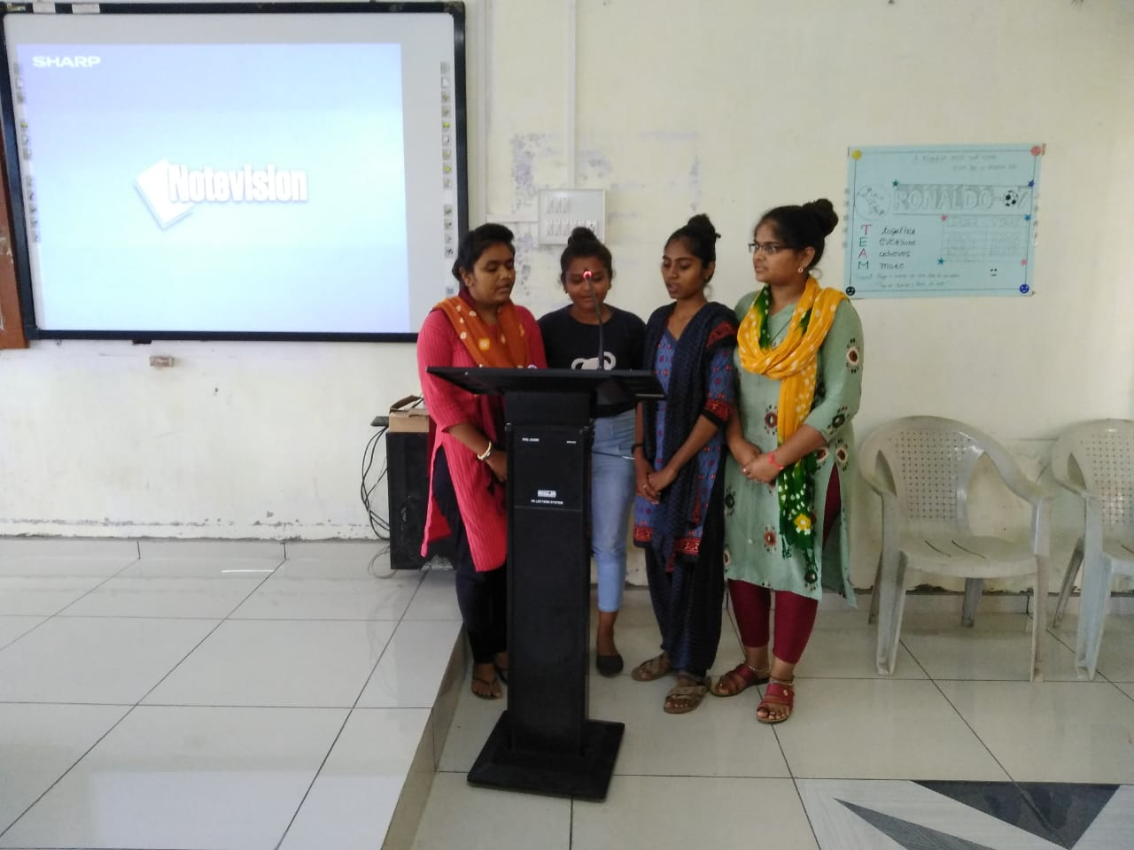

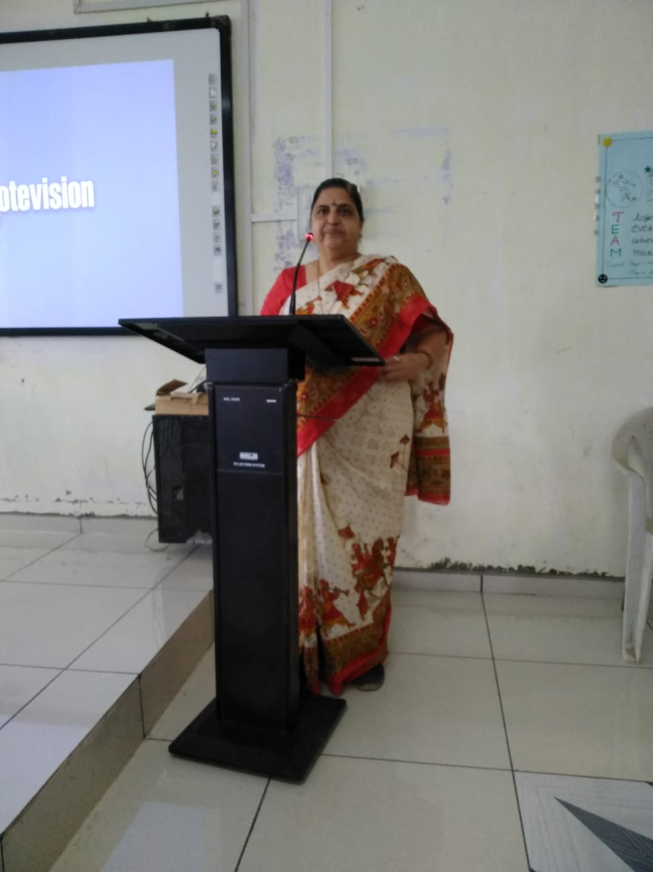

Celebration Of **“International Women Day”**

& Organized A Program Of Film Songs As A Tribute To Shri Lata Mangeshkar 3/3/2022

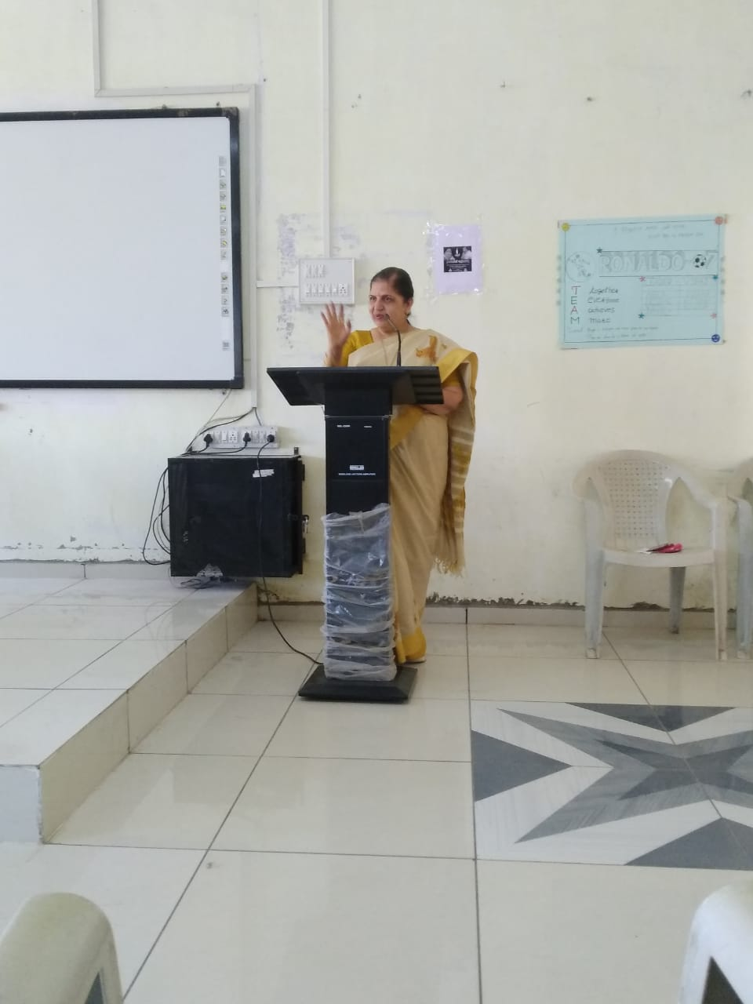

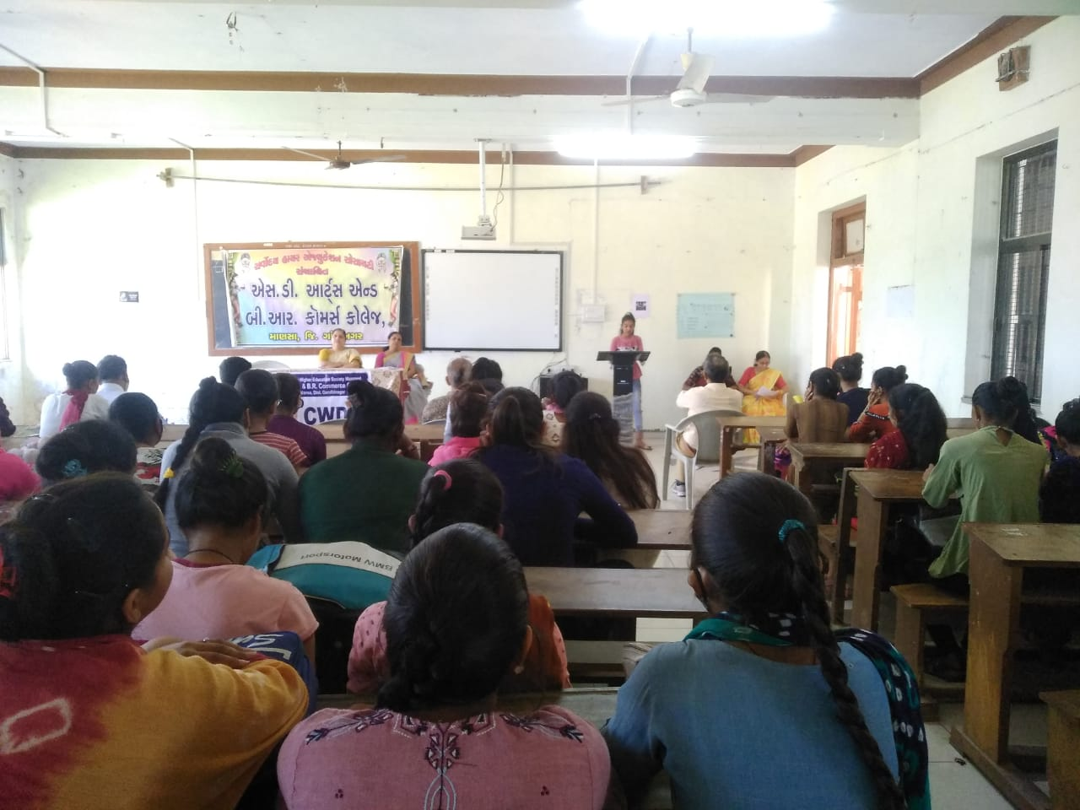

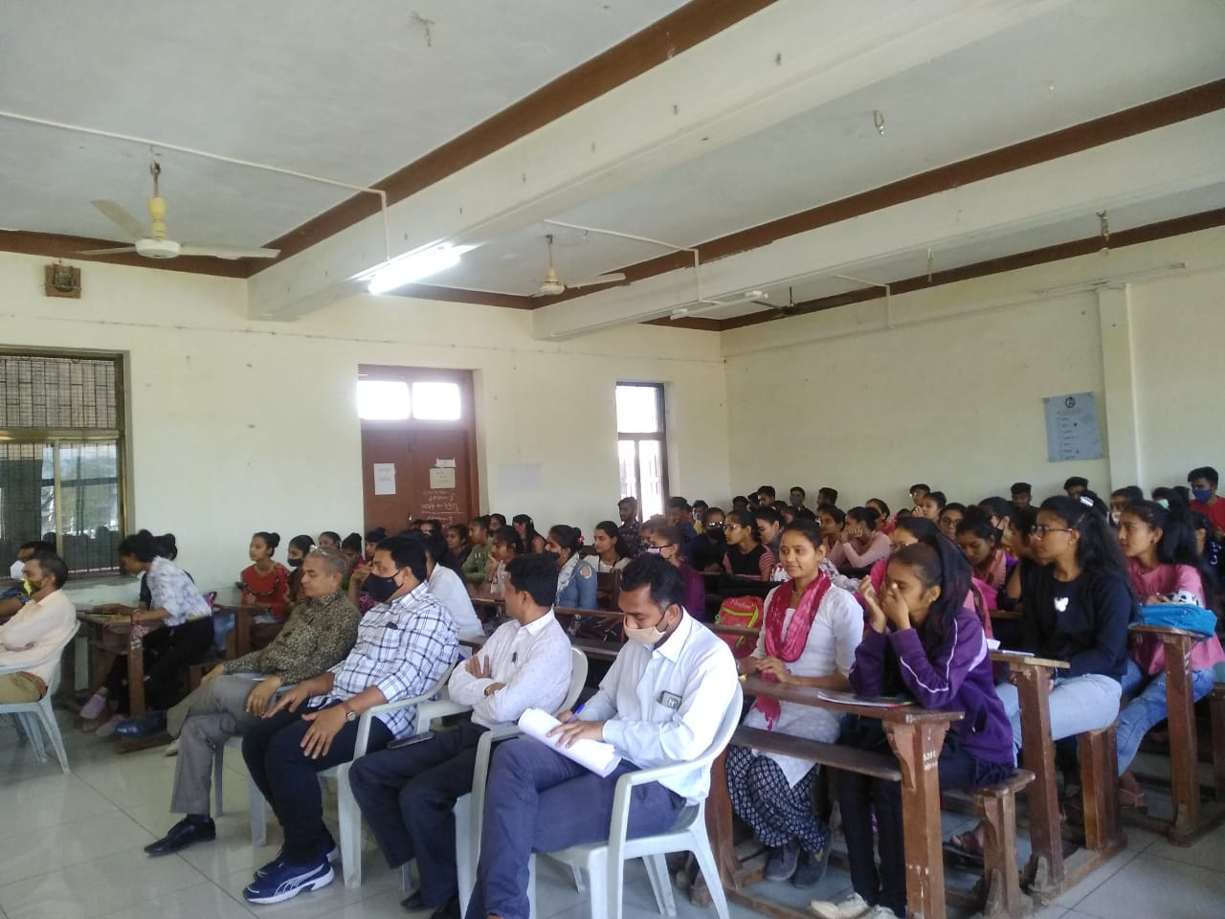

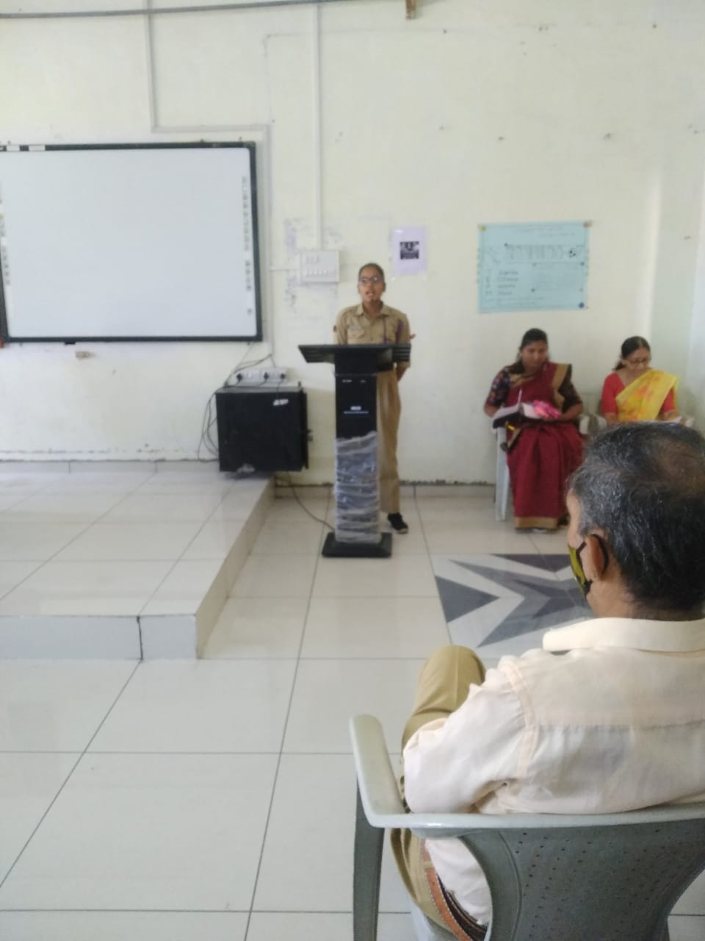

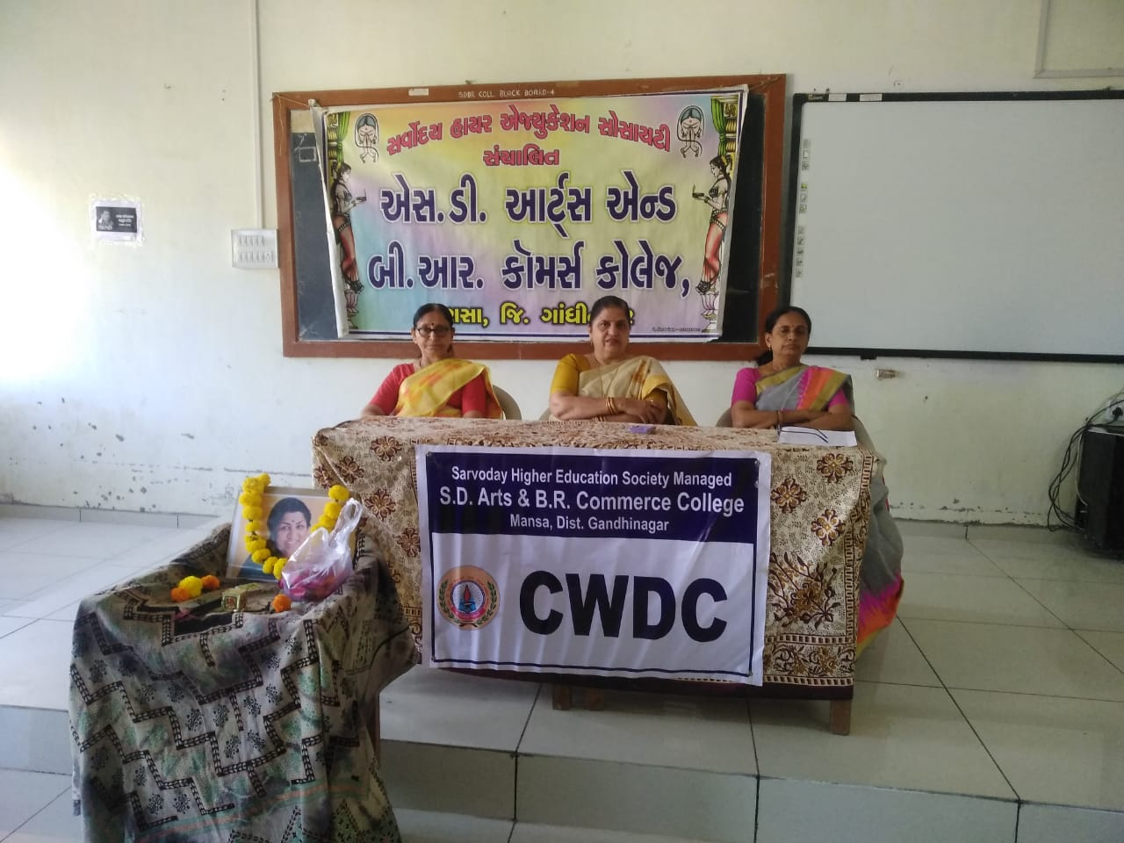

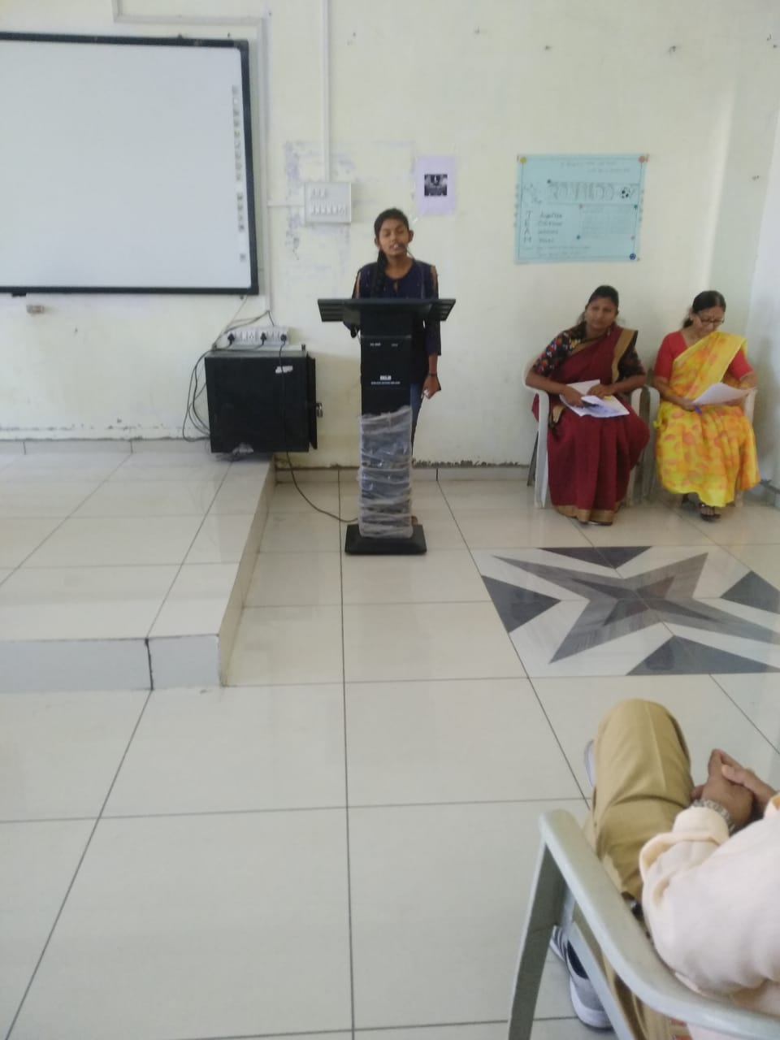

Organized Elocution Program On **“Woman’s Upliftment” 8/3/2022**

